Farm2Store
A Project Report Submitted By
GROUP NO | NAME | ROLL NO
38 | Lodha Dhruvil Nareshbhai | 5020
 | Sadhu Chirag Amrutdas | 5012

In Partial Fulfilment For The Award Of The Degree Of
Bachelor Of Computer Applications
In
Collage Of Computer Application

Navgujarat Collage Of Computer Application

Internal Guide
Prof.Jhanvi Pandya

ACKNOWLEDGEMENT

We Are Pleased To Present This Platform, A Revolutionary Tool Designed To Connect Farmers Directly With Retailers, Eliminating The Need For Intermediaries And Enhancing The Efficiency Of The Agricultural Supply Chain.

Special Thanks To
Farmers:
We Thank Our Farmers For Their Hard Work And Dedication To Providing Fresh Produce.
Retailers:
We Appreciate Our Shopkeepers And Retailers For Their Trust In Our Platform.
Faculty Guide:
I Would Like To Express My Special Thanks To Our Project Guide Prof. Jhanvi Pandya For Her Time And Efforts.
Her Useful Advice And Suggestion Were Really Helpful To Us During The Project Completions.
In This Aspect We Are Eternally Grateful To Her.

We Would Like To Express Our Thanks To Navgujarat Collage Of Computer Application For The Support And The Infrastructure They Have Provided, So We Could Successfully Complete The Project Documentations.

We Commit To Continuously Improving Our Platform For The Benefit Of All Users.

-: INDEX :-

S.No | Title | P.No
1 | INTRODUCTION | 4
2 | EXISTING SYSTEM | 5
3 | PROPOSED SYSTEM | 6
4 | PROJECT PROFILE | 7
5 | HARDWARE AND SOFTWARE REQUIREMENTS | 8
6 | DEVELOPMENT TOOLS AND TECHNOLOGIES | 9
7 | SYTEM FLOW DIAGRAM | 10
8 | UML DIAGRAM | 11
9 | CLASS DIAGRAM | 22
10 | ENITIY RELATIONSHIP DIAGRAM | 23
11 | DATA DICTIONARY | 24

INTRODUCTION
Welcome to Farm2Store
Bridging the Gap between Farmers and Retailers

Our innovative online platform is designed to directly connect farmers with shopkeepers and stores, cutting out the middlemen and ensuring that every transaction is as efficient and transparent as possible.

We believe in creating a direct link between those who grow our food and those who sell it. By enabling farmers to sell their produce directly to retailers, we're not only helping farmers receive fair prices for their goods but also providing retailers with access to high-quality, fresh products.

How It Works
Sign Up: Register as a farmer or retailer and create your profile.
Browse & List: Farmers list their available produce, and retailers browse through a curated selection of products.
Connect & Negotiate: Engage directly with potential buyers or sellers to discuss terms and finalize transactions.
Secure Transactions: Enjoy secure payment options and reliable delivery arrangements.

Existing System
In Existing Traditional Agriculture Trade

1. Limited Access to Markets:

Small-scale farmers often struggle to access larger markets due to Inadequate infrastructure, such as poor transportation networks and lack of storage facilities. This can result in higher transportation costs and spoilage.

2. Middlemen and Intermediaries:

In traditional agricultural trade, multiple intermediaries may be involved between the farmer and the final consumer. Each intermediary takes a cut of the price, which can significantly reduce the share of the final price that farmers receive.

3. Bargaining Power:

Small-scale farmers typically have limited bargaining power compared to larger commercial buyers or traders. This imbalance often results in less favorable pricing terms for the farmers.

Proposed system

Connect.Trade.Thrive
Farm2Store is a new era of agricultural trade, designed to bridge the gap between farmers and retailers. Our innovative online platform empowers farmers to sell their produce directly to shopkeepers and stores, eliminating intermediaries and streamlining the supply chain. By cutting out the middlemen, we help you build stronger, more direct relationships, and achieve better prices and quality.

For Farmers
Showcase Your Produce: List your agricultural products with detailed descriptions, high-quality photos, and pricing information to attract retailers looking for fresh, high-quality goods.
Gain Access to New Markets: Connect with a diverse range of retailers and stores interested in bulk purchases, expanding your reach and growing your business.
Manage Orders Easily: Receive and manage orders directly through our platform, with tools to track shipments and process transactions securely.

For Retailers
Discover Fresh Products: Browse a wide range of agricultural products directly from the source, with options to filter by type, location, and price.
Build Strong Relationships: Communicate directly with farmers to negotiate terms, place bulk orders, and ensure you get the best quality and value for your store.
Streamline Your Supply Chain: Simplify your procurement process with direct ordering, secure payments, and efficient delivery options.

Project Profile

Project Title :- Farm2Store
Internal Guide :- Prof . Jhanvi Pandya
Project Duration :- 1-Year
Developed In :- React, Asp.Net Core
Group No :- 38
Group Member :- SADHU CHIRAG (5012)
LODHA DHRUVIL(5020)

Presented To :- Navgujarat Collage Of Computer Application

Tools And Technology

Fontend:
- Designing : HTML , CSS ,Bootstrap
- Technology : React
Backend:
- Technology : Asp.Net Core
- Database : Sql Server

haRDWARE & SOFTWARE REQUIREMENTS

Server-Side Hardware Requirements:
- Processor : Core i3 or higher
- RAM : 8 GB
- Hard Disk : 512 GB

Server-Side Software Requirements:
- Back-End : Asp.Net Core 8.0
- Front-End : React Js , Bootstrap
- Database : Sql Server
- Operating System : Windows 7 or Higher

Client-Side Requirements:
- Operating System : Windows 7 or Higher
- Browser : Internet Explorer 8 Or Higher, Edge, Firefox 28 or Higher, Google Chrome 34 Or Higher
- Processor : Core i3 or higher
- RAM : 8 GB
- Hard Disk : 512 GB

SYSTEM FLOW DIAGRAM

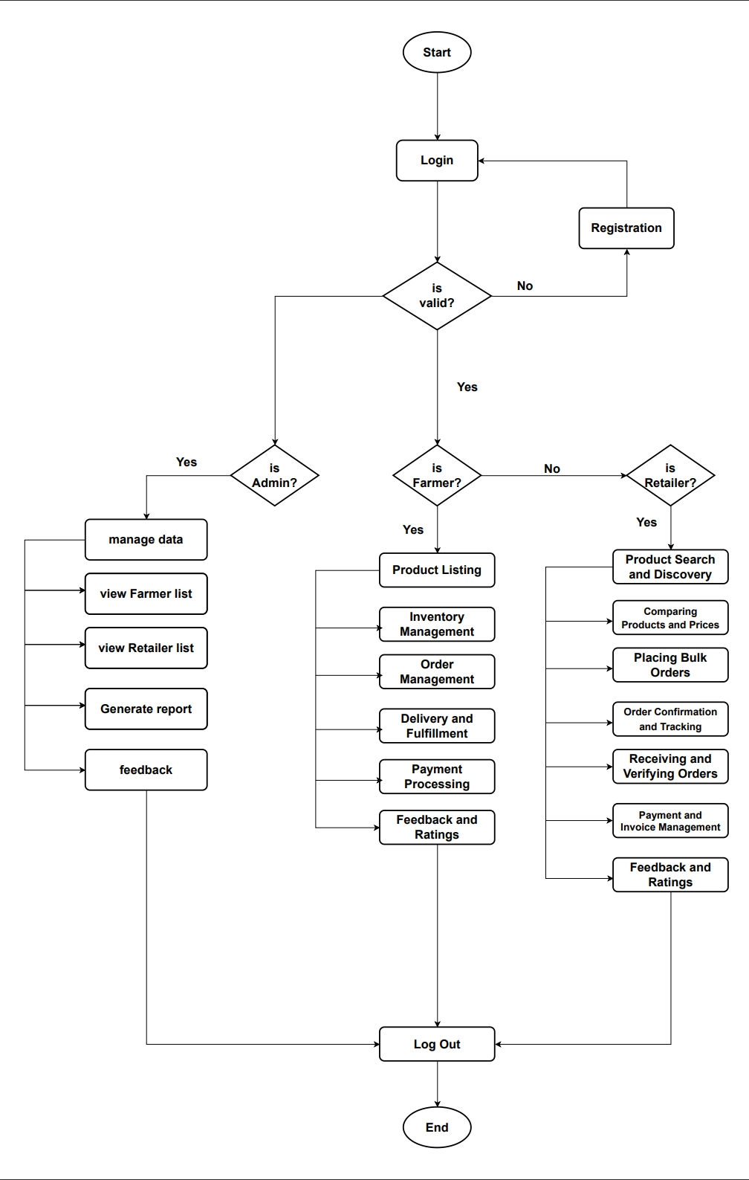
aDMIN USE-CASE DIAGRAM
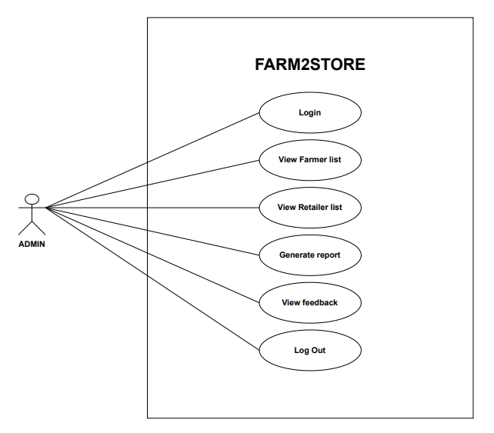

FARMER USE-CASE DIAGRAM
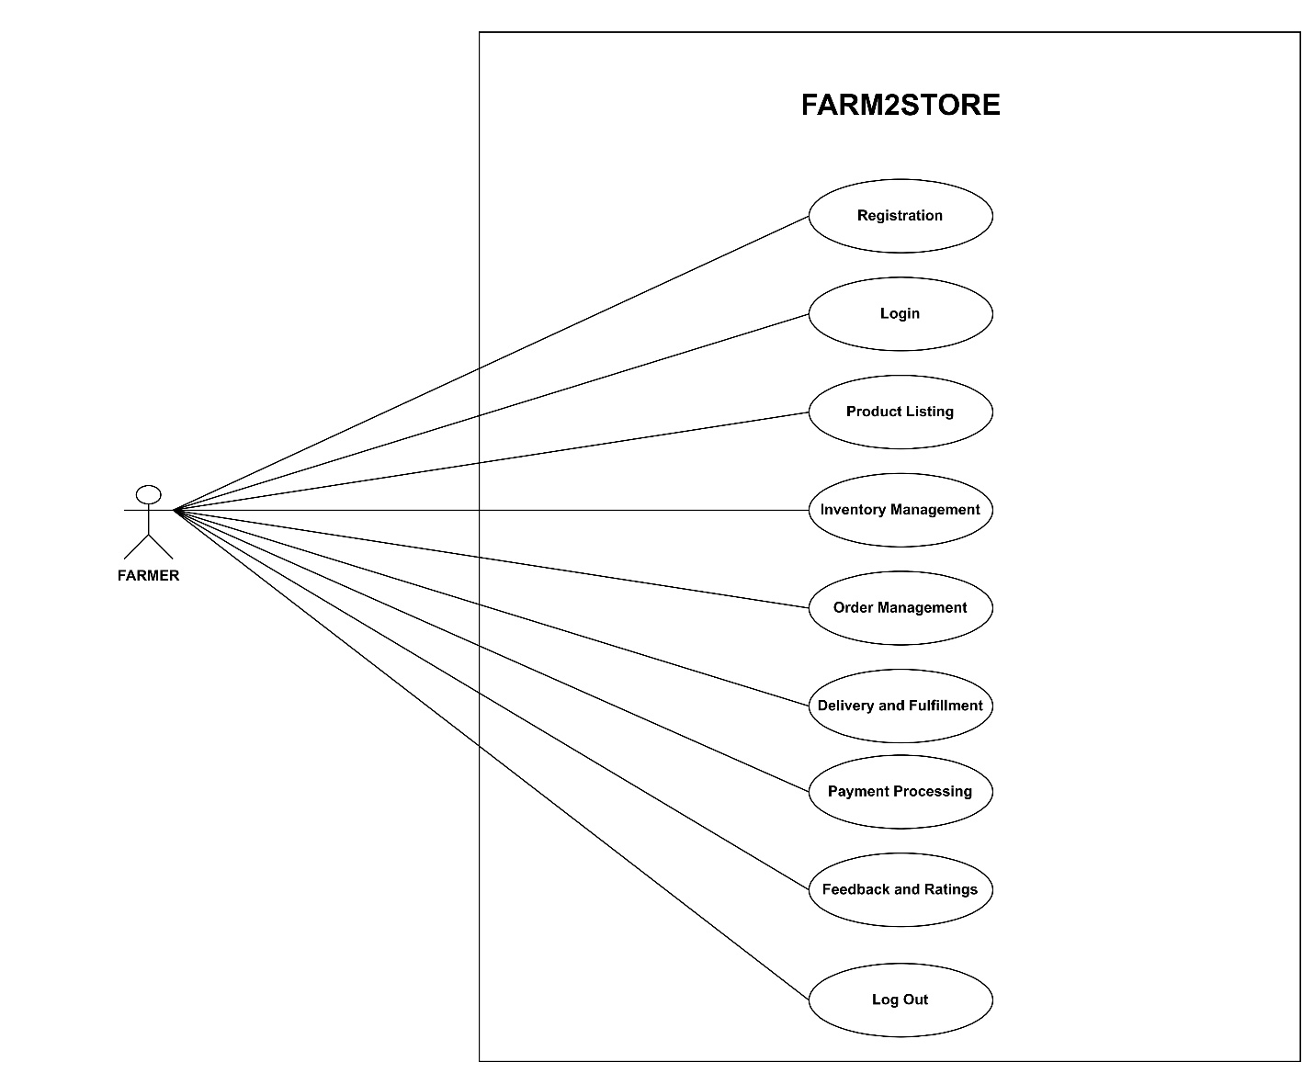

RETAILER USE-CASE DIAGRAM
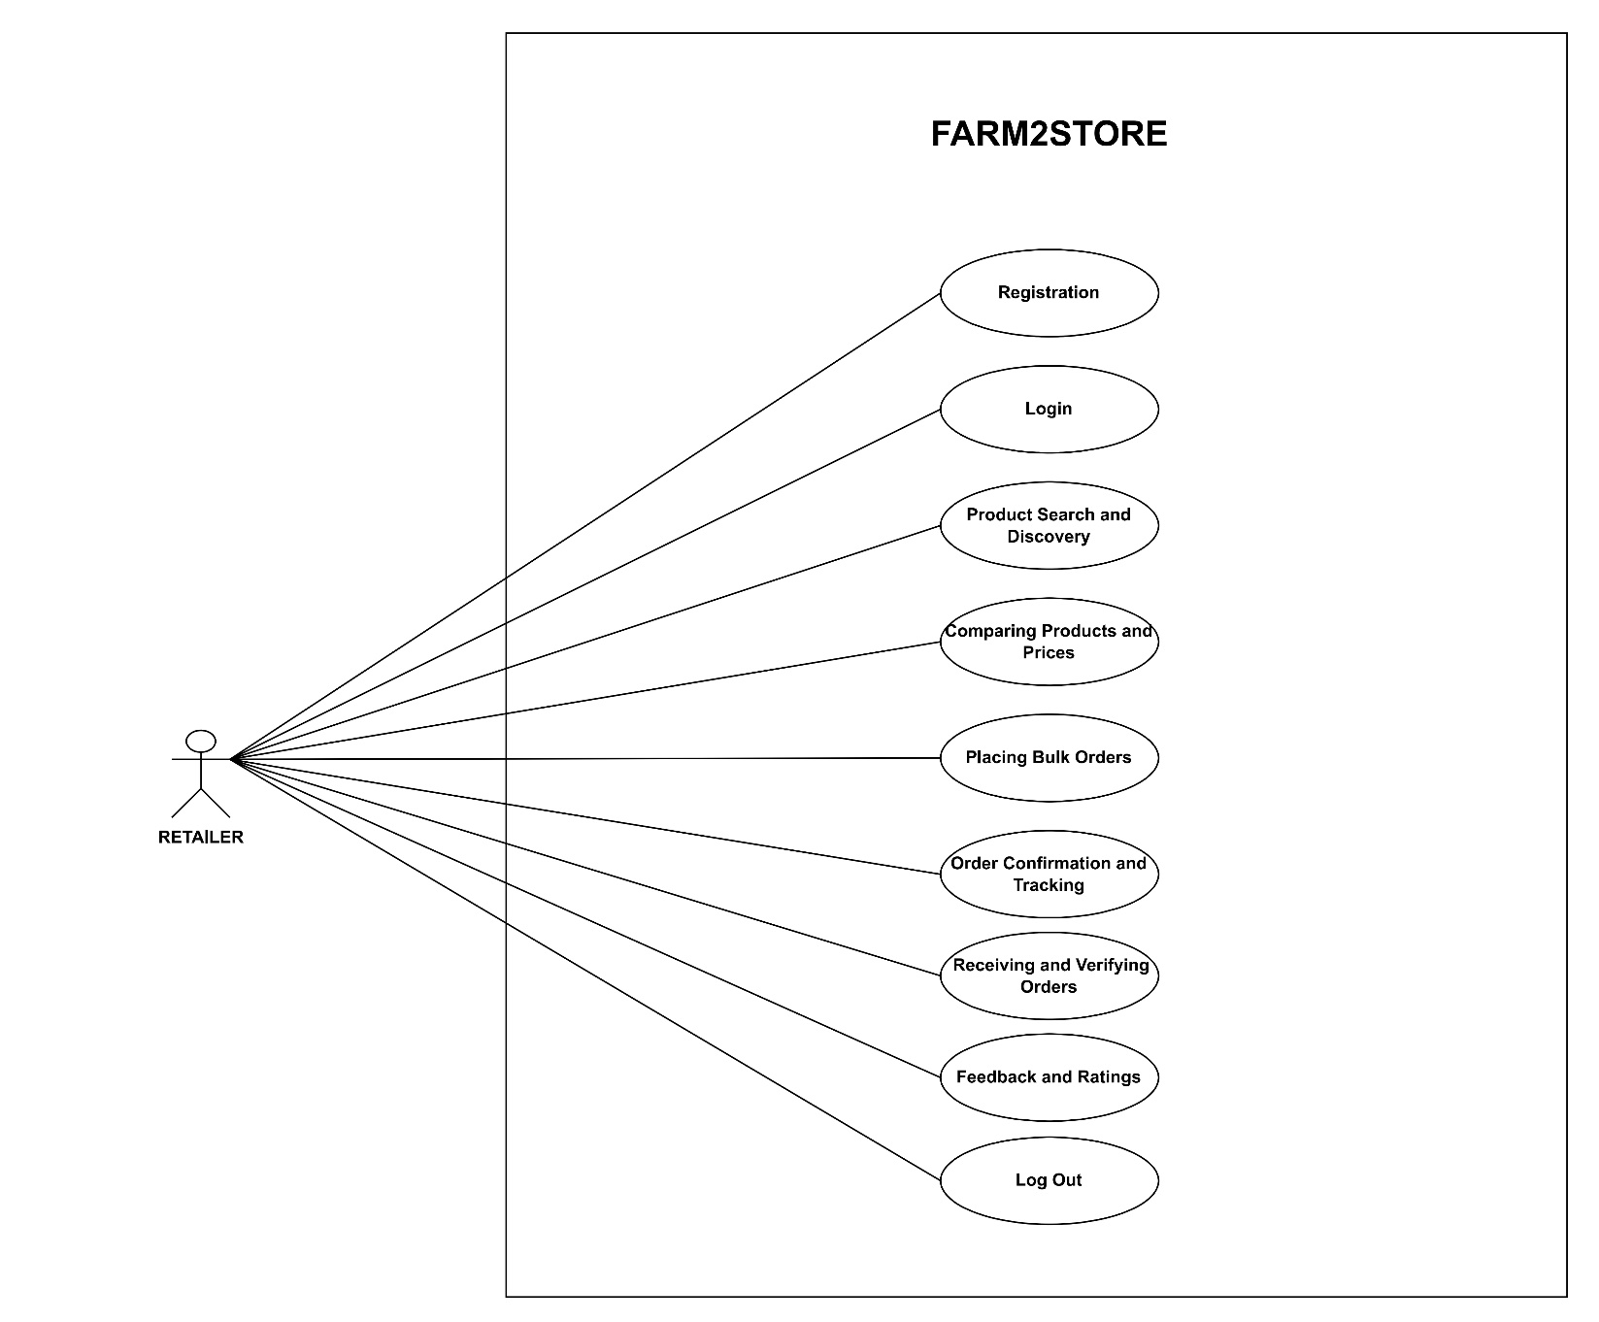

LOGIN SEQUENCE DIAGRAM

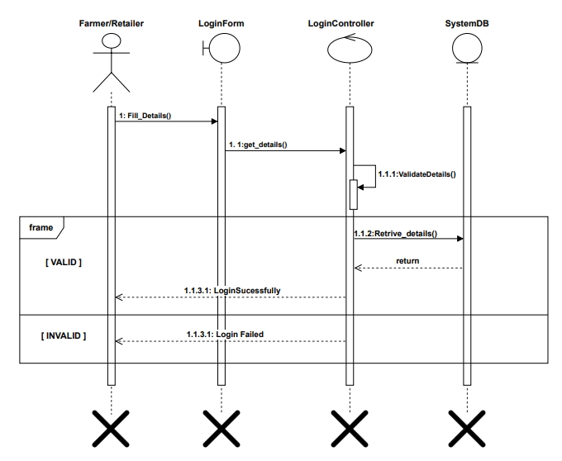

REGISTRATION SEQUENCE DIAGRAM
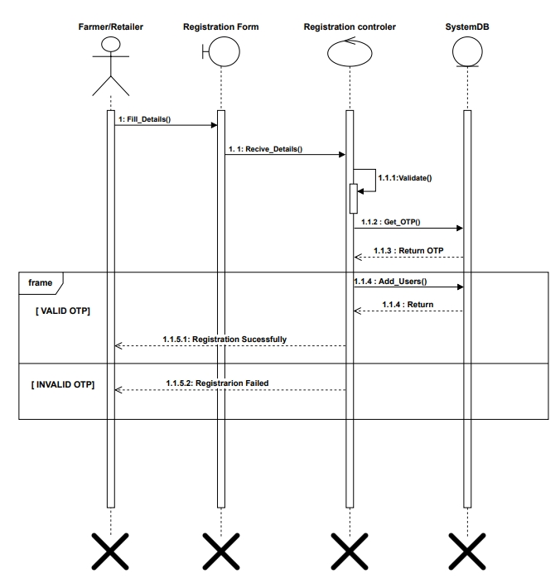

Manage profile SEQUENCE DIAGRAM
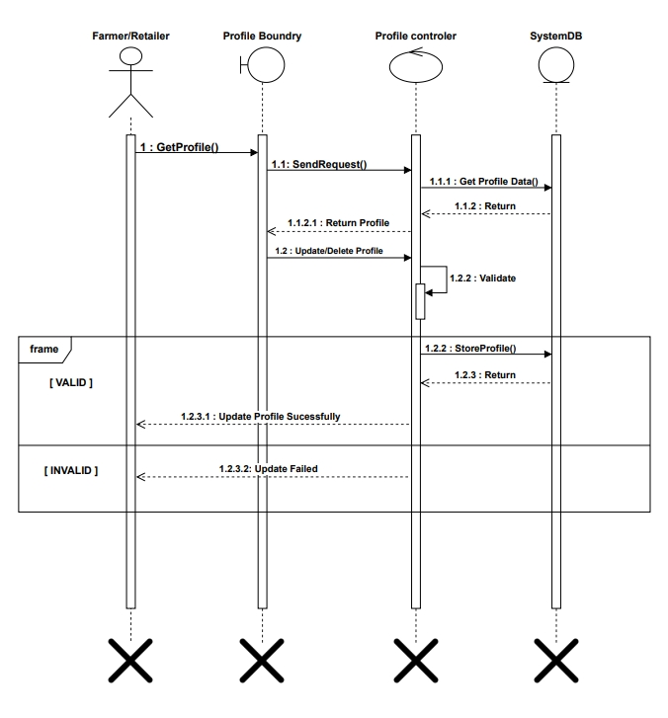

PAyment SEQUENCE DIAGRAM
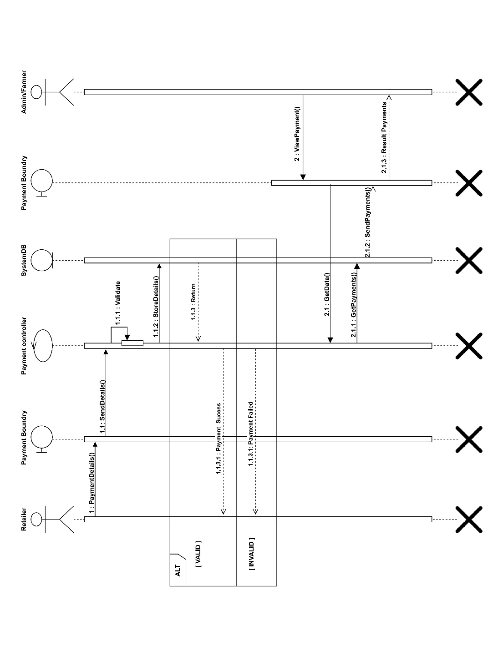

feedback SEQUENCE DIAGRAM
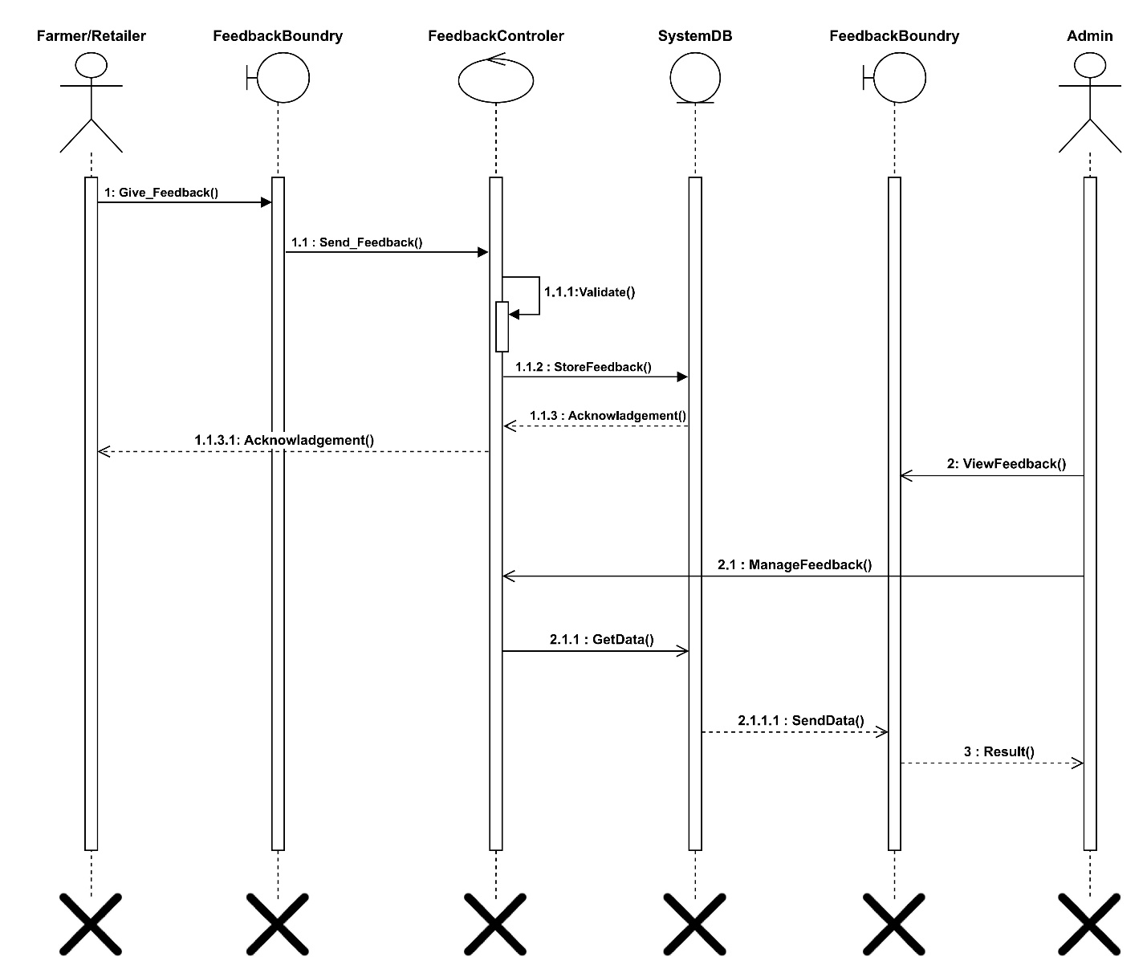

Placing order activity DIAGRAM
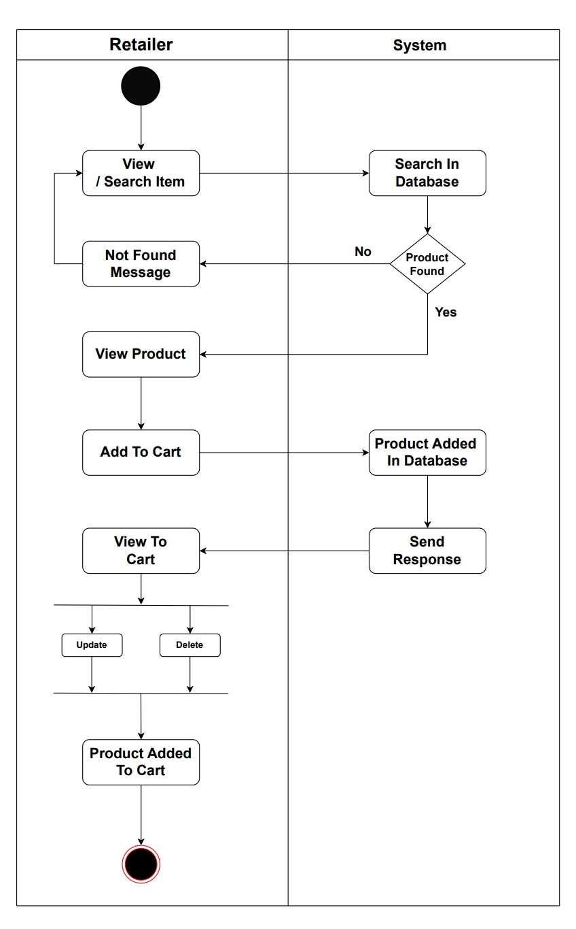

manage category activity DIAGRAM
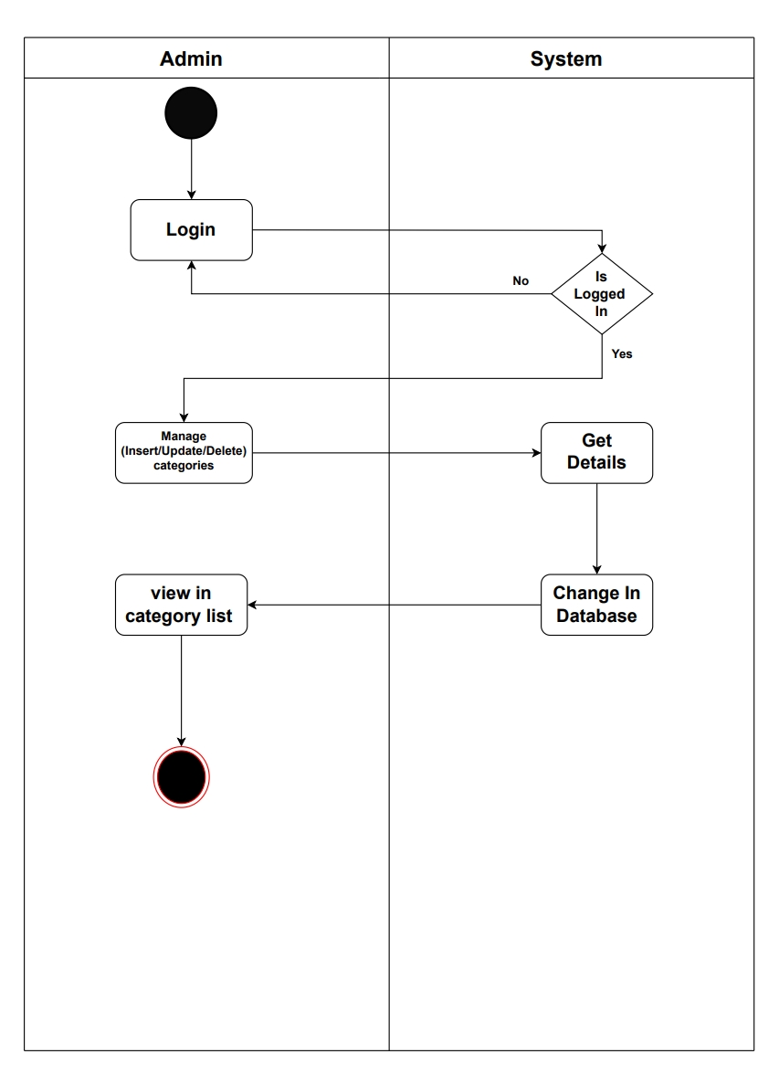

Manage inventory activity diagram
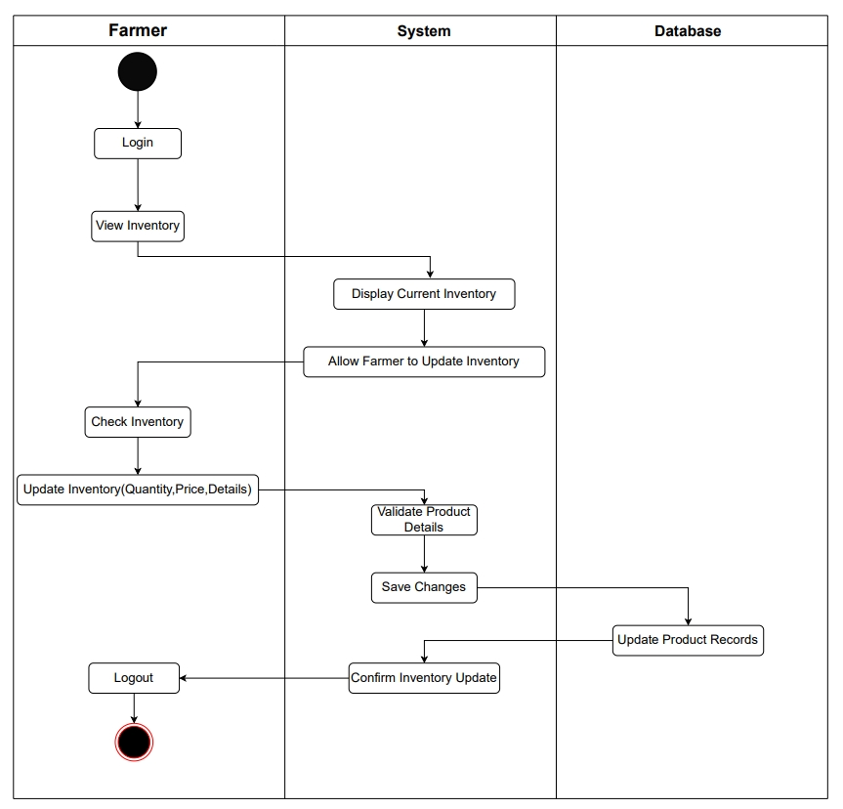

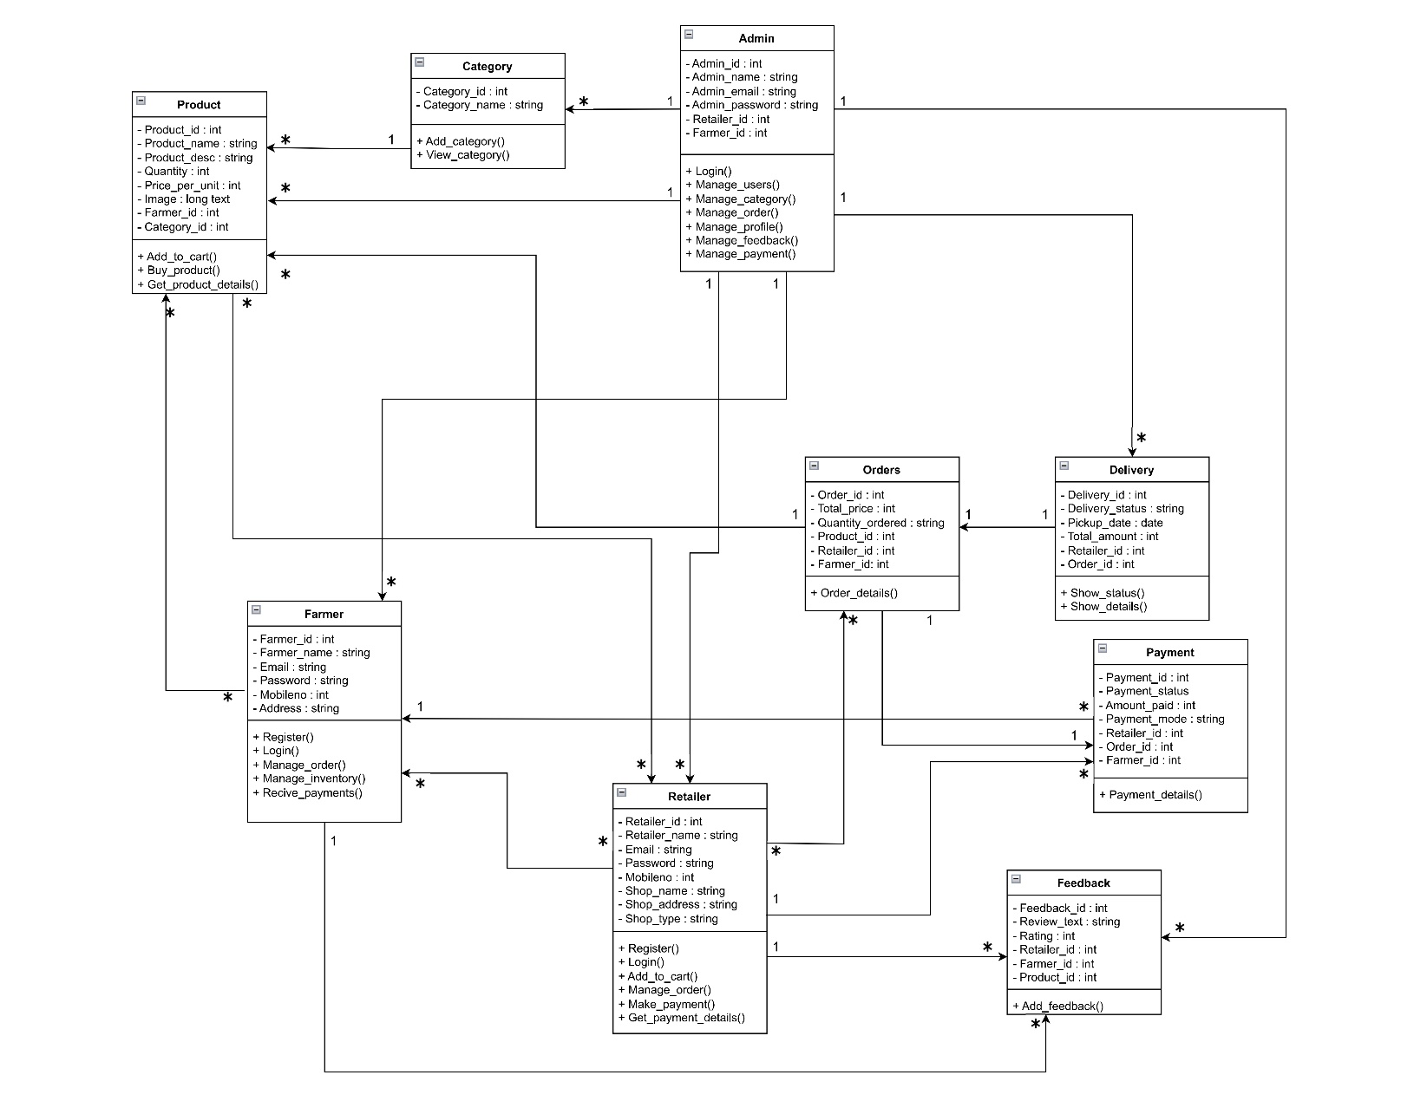
class DIAGRAM

ER DIAGRAM
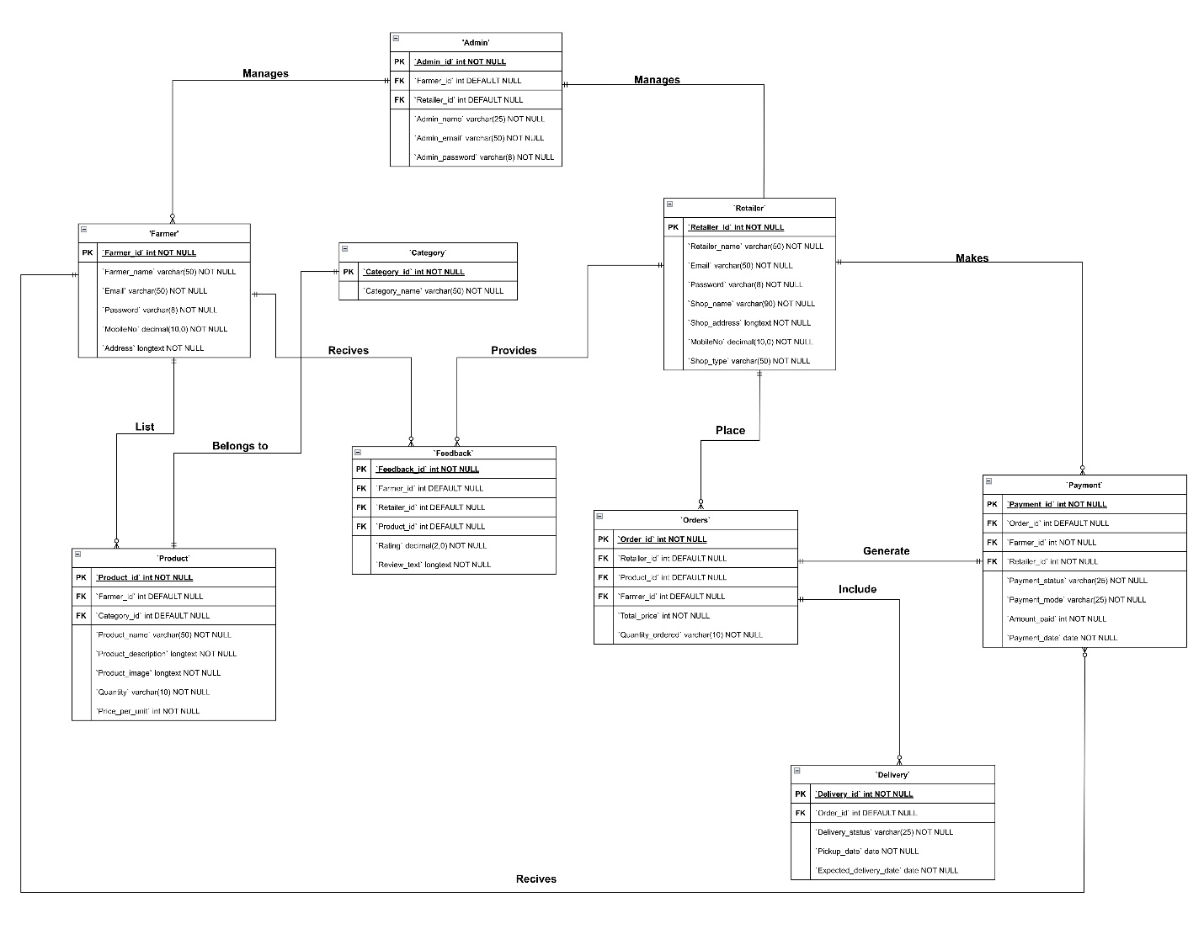

DATA DICTIONARY
ATTRIBURE | CONSTRAIN | DATATYPE | SIZE | DESCRIPTION
ADMIN_ID | PRIMARY KEY | INT |  | PRIMARY KEY FOR ADMIN TABLE, UNIQUE FOR EVERY ROW
ADMIN_NAME | NOT NULL | VARCHAR | 25 | NAME OF ADMIN
ADMIN_EMAIL | NOT NULL | VARCHAR | 50 | ADMIN EMAIL ADDRESS
ADMIN_PASSWORD | NOT NULL | VARCHAR | 8 | ADMIN PASSWORD
RETAILER_ID | FOREIGN KEY | INT |  | MAPPED WITH RETAILER TABLE
FARMER_ID | FOREIGN KEY | INT |  | MAPPED WITH FARMER TABLE

1. ADMIN

2. FARMER
ATTRIBURE | CONSTRAIN | DATATYPE | SIZE | DESCRIPTION
FARMER_ID | PRIMARY KEY | INT |  | PRIMARY KEY FOR FARMER TABLE,UNIQUE FOR EVERY ROW
FARMER_NAME | NOT NULL | VARCHAR | 50 | NAME OF FARMER
EMAIL | NOT NULL | VARCHAR | 50 | FARMER EMAIL
PASSWORD | NOT NULL | VARCHAR | 8 | FARMER PASSWORD
MOBILENO | NOT NULL | NUMERIC | 10 | FARMER MOBILE NO
ADDRESS | NOT NULL | LONGTEXT |  | FARM ADDRESS

3. RETAILER
ATTRIBURE | CONSTRAIN | DATATYPE | SIZE | DESCRIPTION
RETAILER_ID | PRIMARY KEY | INT |  | PRIMARY KEY FOR RETAILER TABLE,UNIQUE FOR EVERY ROW
RETAILER_NAME | NOT NULL | VARCHAR | 50 | NAME OF RETAILER
EMAIL | NOT NULL | VARCHAR | 50 | RETAILER EMAIL
PASSWORD | NOT NULL | VARCHAR | 8 | RETAILER PASSWORD
SHOP_NAME | NOT NULL | VARCHAR | 90 | RETAILER SHOP NAME
SHOP_ADDRESS | NOT NULL | LONGTEXT |  | RETAILER SHOP ADDRESS
MOBILENO | NOT NULL | NUMERIC | 10 | RETAILER MOBILE NO
SHOP_TYPE | NOT NULL | VARCHAR | 50 | RETAILER SHOP TYPE

4. PRODUCT
ATTRIBURE | CONSTRAIN | DATATYPE | SIZE | DESCRIPTION
PRODUCT_ID | PRIMARY KEY | INT |  | PRIMARY KEY FOR PRODUCT TABLE,UNIQUE FOR EVERY ROW
PRODUCT_NAME | NOT NULL | VARCHAR | 50 | NAME OF PRODUCT
PRODUCT_DESCRIPTION | NOT NULL | LONGTEXT |  | DESCRIPTION OF PRODUCT
PRODUCT_IMAGE | NOT NULL | LONGTEXT |  | IMAGE OF PRODUCT
QUANTITY | NOT NULL | VARCHAR | 10 | PRODUCT OF QUANTITY
PRICE_PER_UNIT | NOT NULL | INT |  | PRICE PER UNIT OF PRODUCT
FARMER_ID | FOREIGN KEY | INT |  | MAPPED WITH FARMER TABLE
CATEGORY_ID | FOREIGN KEY | INT |  | MAPPED WITH CATEGORY TABLE

5.CATEGORY
ATTRIBURE | CONSTRAIN | DATATYPE | SIZE | DESCRIPTION
CATEGORY_ID | PRIMARY KEY | INT |  | PRIMARY KEY FOR CATEGORY TABLE,UNIQUE FOR EVERY ROW
CATEGORY_NAME | NOT NULL | VARCHAR | 50 | NAME OF CATEGORY

6. ORDERS
ATTRIBURE | CONSTRAIN | DATATYPE | SIZE | DESCRIPTION
ORDER_ID | PRIMARY KEY | INT |  | PRIMARY KEY FOR ORDER TABLE,UNIQUE FOR EVERY ROW
QUANTITY_ORDERED | NOT NULL | VARCHAR | 10 | OAUNTITY OF PRODUCT ORDERED
TOTAL_PRICE | NOT NULL | INT |  | TOTAL PRICE OF ORDER
RETAILER_ID | FOREIGN KEY | INT |  | MAPPED WITH RETAILER TABLE
PRODUCT_ID | FOREIGN KEY | INT |  | MAPPED WITH PRODUCT TABLE
FARMER_ID | FOREIGN KEY | INT |  | MAPPED WITH FARMER TABLE

7. DELIVERY
ATTRIBURE | CONSTRAIN | DATATYPE | SIZE | DESCRIPTION
DELIVERY_ID | PRIMARY KEY | INT |  | PRIMARY KEY FOR DELIVERY TABLE,UNIQUE FOR EVERY ROW
DELIVERY_STATUS | NOT NULL | VARCHAR | 10 | STATUS OF DELIVERY
PICKUP_DATE | NOT NULL | DATE |  | PICKUP DATE FOR DELIVERY
EXPECTED_DELIVERY_DATE | NOT NULL | DATE |  | EXPECTED DATE FOR DELIVERY
ORDER_ID | FOREIGN KEY | INT |  | MAPPED WITH ORDER TABLE

8. PAYMENT
ATTRIBURE | CONSTRAIN | DATATYPE | SIZE | DESCRIPTION
PAYMENT_ID | PRIMARY KEY | INT |  | PRIMARY KEY FOR PAYMENT TABLE,UNIQUE FOR EVERY ROW
PAYMENT_STATUS | NOT NULL | VARCHAR | 25 | STATUS OF PAYMENT
PAYMENT_MODE | NOT NULL | VARCHAR | 25 | MODE OF PAYMENT
AMOUNT_PAID | NOT NULL | INT |  | AMOUNT PAID FOR ORDER
PAYMENT_DATE | NOT NULL | DATE |  | DATE OF PAYMENT
RETAILER_ID | FOREIGN KEY | INT |  | MAPPED WITH RETAILER TABLE
FARMER_ID | FOREIGN KEY | INT |  | MAPPED WITH FARMER TABLE
ORDER_ID | FOREIGN KEY | INT |  | MAPPED WITH ORDER TABLE

9. FEEDBACK
ATTRIBURE | CONSTRAIN | DATATYPE | SIZE | DESCRIPTION
FEEDBACK_ID | PRIMARY KEY | INT |  | PRIMARY KEY FOR FEEDBACK TABLE,UNIQUE FOR EVERY ROW
RATING | NOT NULL | INT | 2 | RATING FOR PRODUCT
REVIEW_TEXT | NOT NULL | LONGTEXT |  | REVIEW FOR ORDERS
PRODUCT_ID | FOREIGN KEY | INT |  | MAPPED WITH PRODUCT TABLE
RETAILER_ID | FOREIGN KEY | INT |  | MAPPED WITH RETAILER TABLE
FARMER_ID | FOREIGN KEY | INT |  | MAPPED WITH FARMER TABLE

